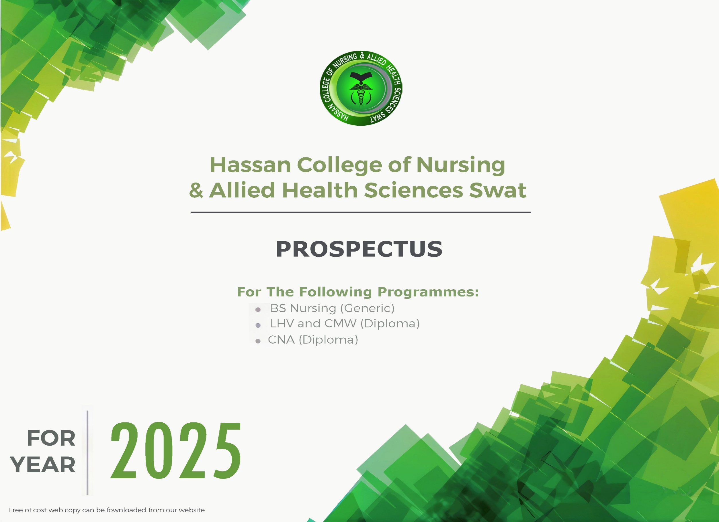





PHILOSOPHY
The philosophy of Hassan College of Nursing is congruent with the philosophy of Hassan Medical complex Health Center and reflects the belief of the faculty and administration that each individual is sacred and possesses inherent personal worth and dignity. We believe that each student is a unique being whose culture, intellectual development, and spiritual attributes affect his/her ability to seek, find, and use health information and resources in order to critically think and make decisions using evidence-based information.

VISION
The Hassan College of Nursing is a leading institute in the field of nursing education that ensure outstanding educational outcomes exemplified by graduates who will be recognized for excellence, leadership and compassionate care nationally and internationally.

MISSION
To provide conducive learning environment to the student without any discrimination based on their color, race, and gender, and marital status, sociocultural, religious and political background.
To educate and inspire students to become passionate healers who demonstrate integrity, innovation, caring attitude, excellence in service delivery and culturally appropriate care.
To equip the students with knowledge and skills utilizing evidence-based teaching and learning methodologies.

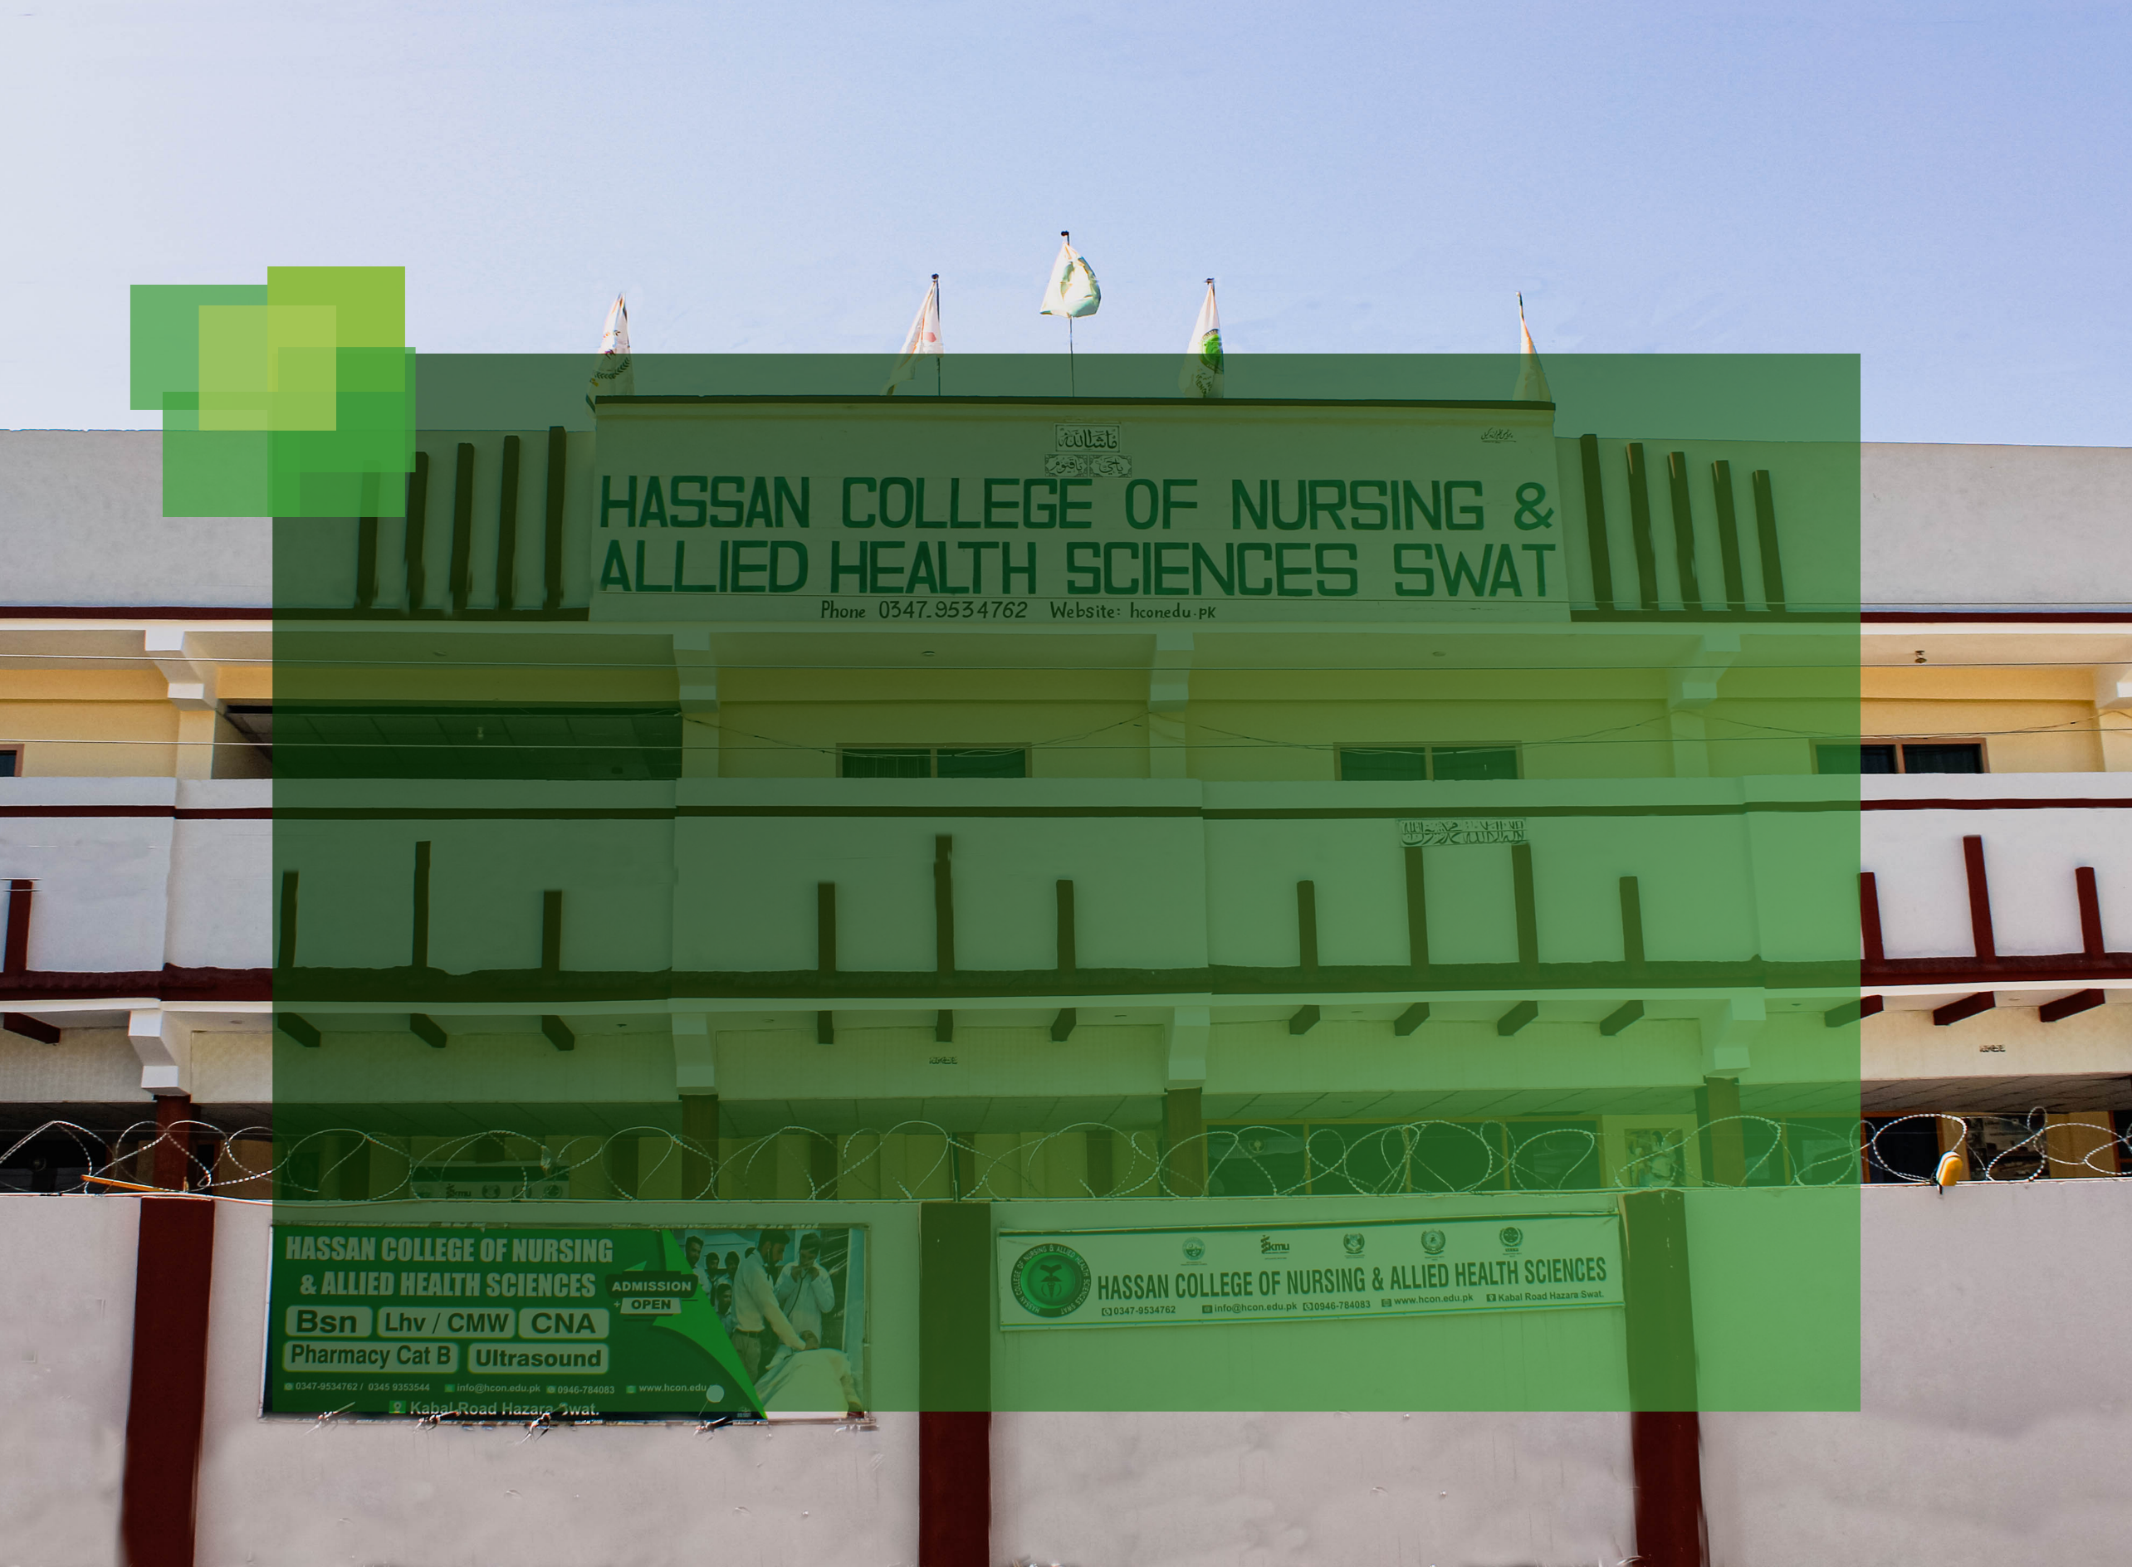

OBJECTIVES OF THE COLLEGE

- To provide quality education to enable individuals to realize their full potential to meet the needs of a wide range of health care system and social setup.
- To prepare individual who can provide safe and culturally appropriate care to the patients, families and communities.
- To facilitate and supervise students’ learning in skills performance.

- To produce care providers who can practice safe, holistic and effective patient/family centered care by using science-based frameworks to promote and maintain health, prevent disease, and manage illness.
- To enhance therapeutic communication skills and build character, professional ethics and moral values.

- To guide students for research activity and build research links locally, nationally and internationally for setting and boosting up the culture of research.

- To enhance leadership and management skills in order to improve health care system.

MESSAGE FROM THE DIRECTOR HCN SWAT

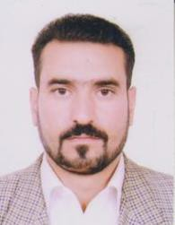
A warm Welcome in Hassan College of Nursing and Allied Health Sciences. This is an exciting time to be embarking on a career in healthcare and the ever-changing field of nursing. It's a matter of pride to be a nurse in the present millennium the nurses are faced with the challenges of advancing technology, informatics system, modern demands & Development. Our mission is to develop competent students with good value system. Capable enough to face challenges of the ever changing and competent world. Experience and quality faculty members are part of the system to nurture students. Individual talents
and innovations are constantly encouraged by the management to achieve excellence in education discipline and ethical behavior are given utmost importance in the process of molding students in different branches. It can firmly assure that the students are not only trained for becoming a nurse but to become a perfectionist in this nursing profession Wish you all the best.

Shawkat Zarin
RN, BSCN.DIPICU/CCU, MPH.



Gulzar Habibullah
RN, MSN, BSN


The Hassan College of Nursing and Allied Health Sciences Swat is an organization that utilizes research proven teaching and learning methodologies to educate students across the country.
The Hassan College of Nursing (HCN) was established in 2018. Initially, it started functioning in Hassan Medical Complex Swat. The college shifted in current building in 2020.
The HCN is registered with Pakistan Nursing Council Islamabad (letter No PNC F-7-186- Admin/2019/2753) in Sept 5th 2019, affiliated with Khyber Medical University (No.1808/Dir/Admissions/KMU) in Oct. 1st 2020, Higher Education Regulatory Authority (No.376/COLLEGES in Nov. 13th 2019 and Nursing Examination Board Peshawar.
The HCN took its first batch of 4 years BSc Nursing, 2 years LHV (diploma) and 2 years CMW (diploma) in 2020.

This College is equipped with all the latest teaching learning resources, enthusiastic faculty and supporting staff. The HCN is a platform for nursing students to achieve the desired outcomes for higher education.

ABOUT
COLLEGE

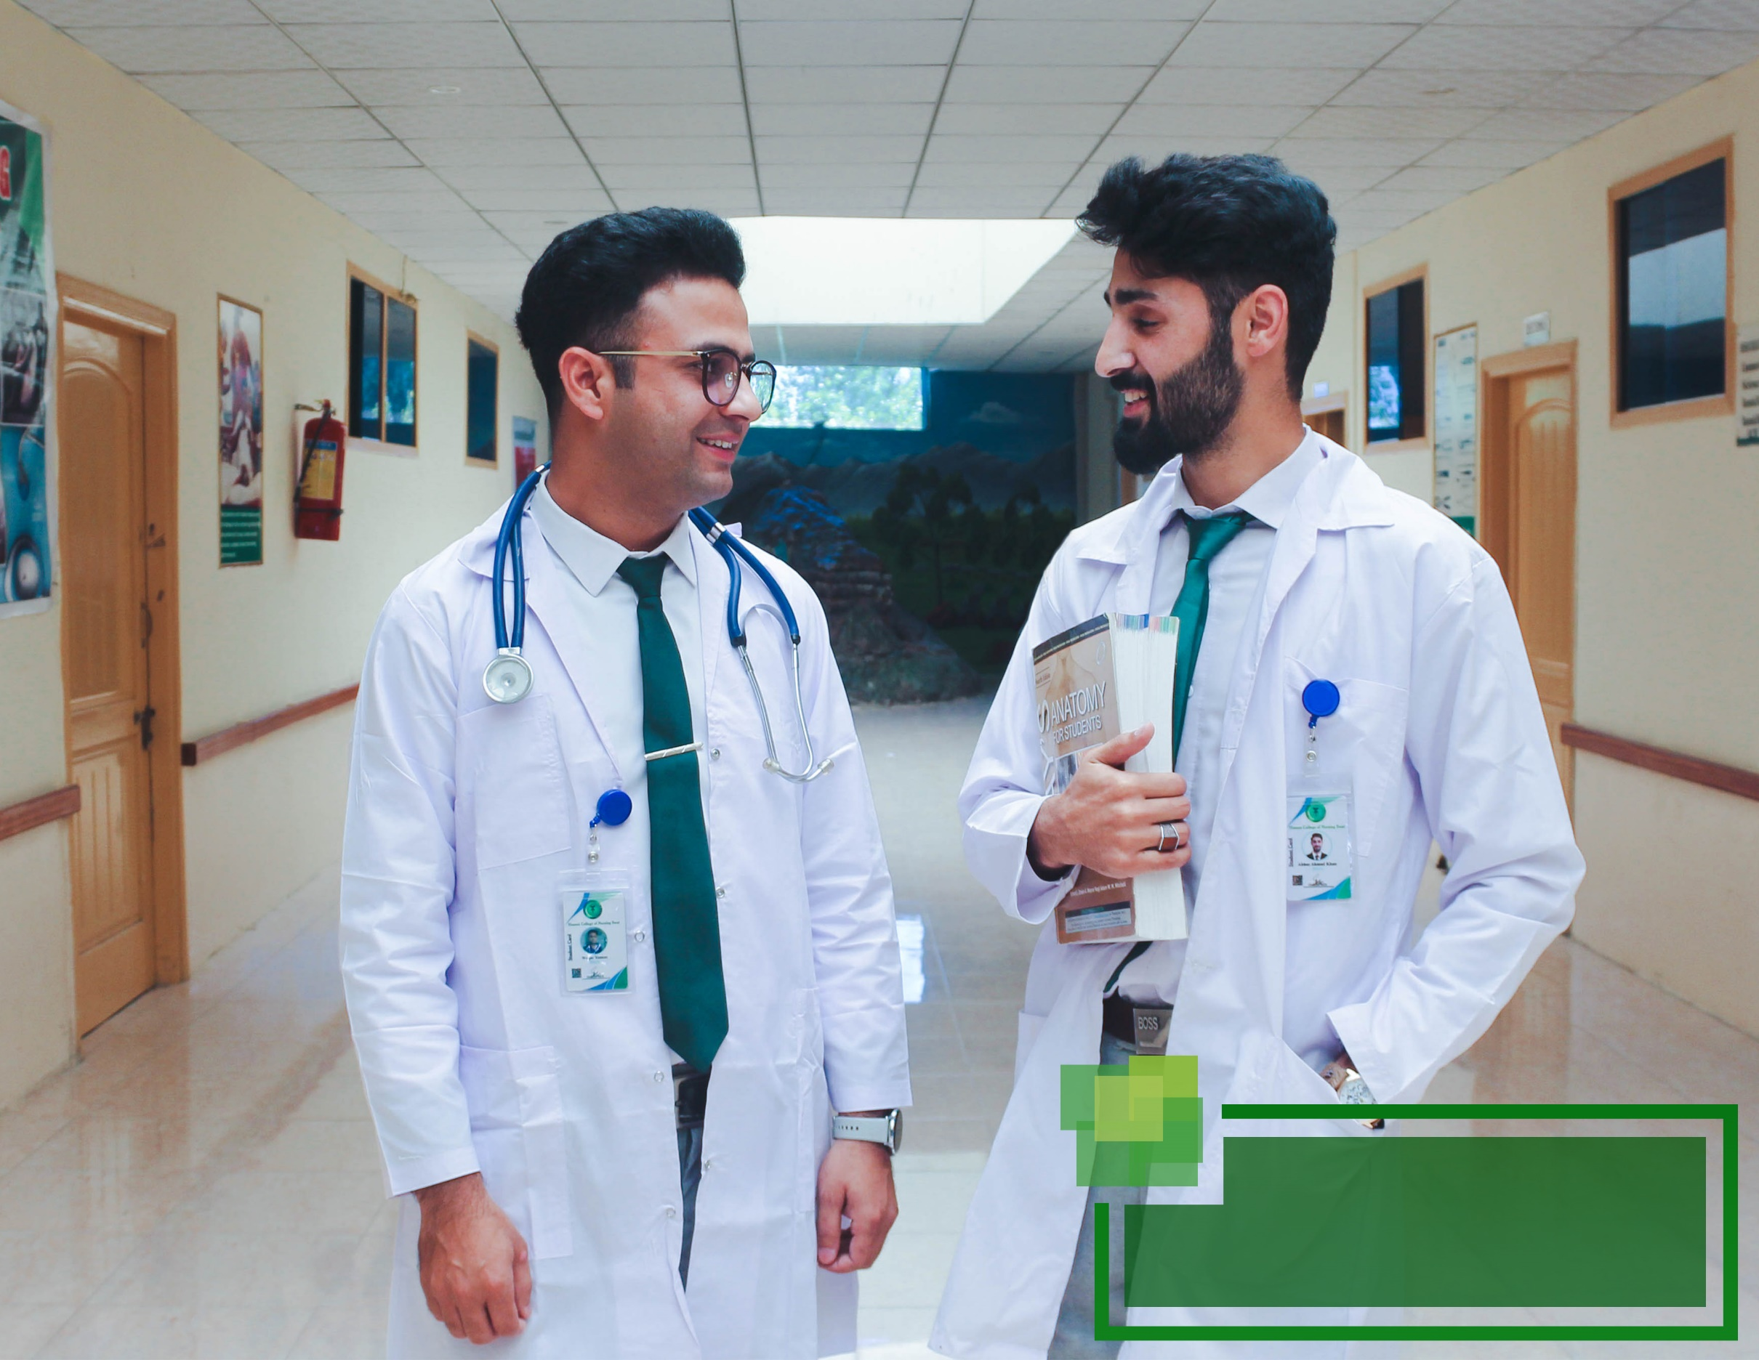

Learning Resources

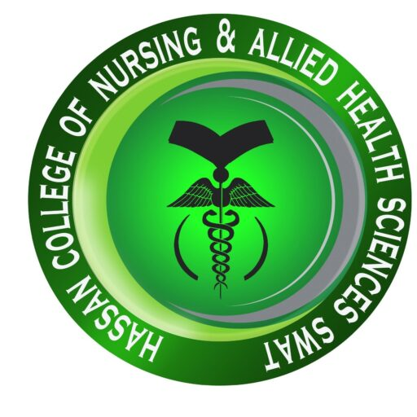
The college has an open door policy for its library and students are encouraged to use it to its full potential.

The library is managed by subject specialist staff which results in a well-managed, sorted and accessible collection.

Furthermore, the staff is trained to help students in the most efficient manner aiding their quick access to all the library resources.

Library

Our newly formed digital library also holds a huge array of up to date books and journals.
A fast internet connection is also provided for the ease of research for the students.

Additionally, the library archives journals and newspapers for easy access of information pertaining to current affairs.

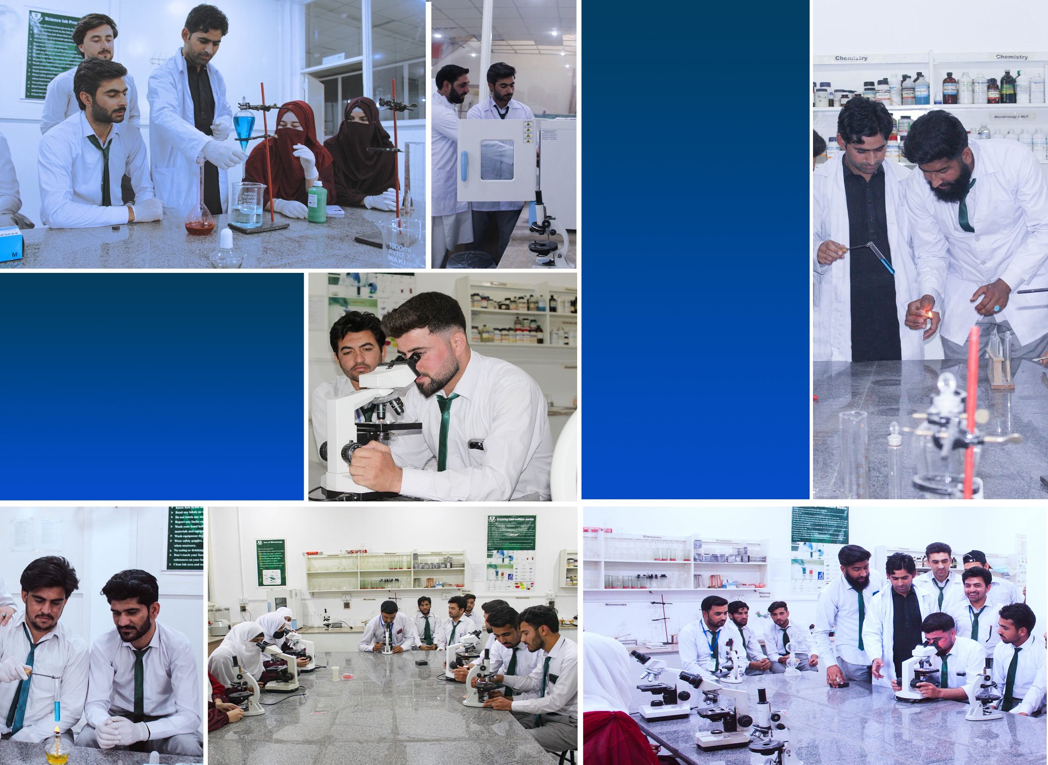
Our science Lab is fully equipped with glassware, microscopes and all other apparatus that even surpasses the regulatory requirements.

Moreover, special care is placed in the Lab safety and the staff is well trained to ensure proper training of our students.

Science Lab

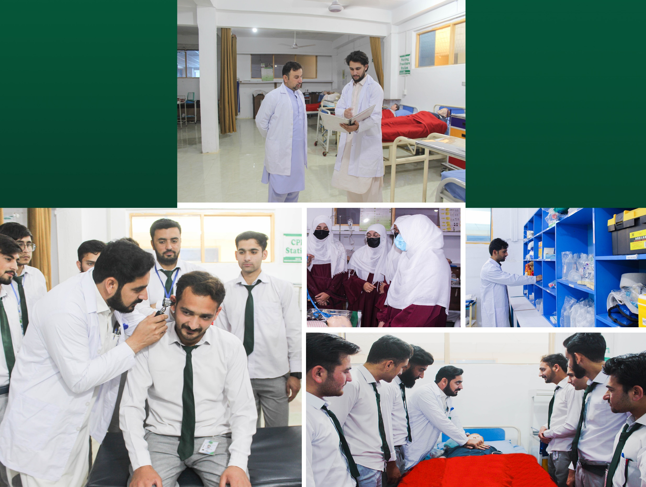

Our skills lab embodies our aim of providing the highest quality education in the region.
It is fully equipped to fulfill all the curriculum requirements
Special care was taken to design its layout to simulate the hospital environment.

Frequent tutorials are arranged in the skills lab to polish students’ skills to the maximum.

Skills
Lab

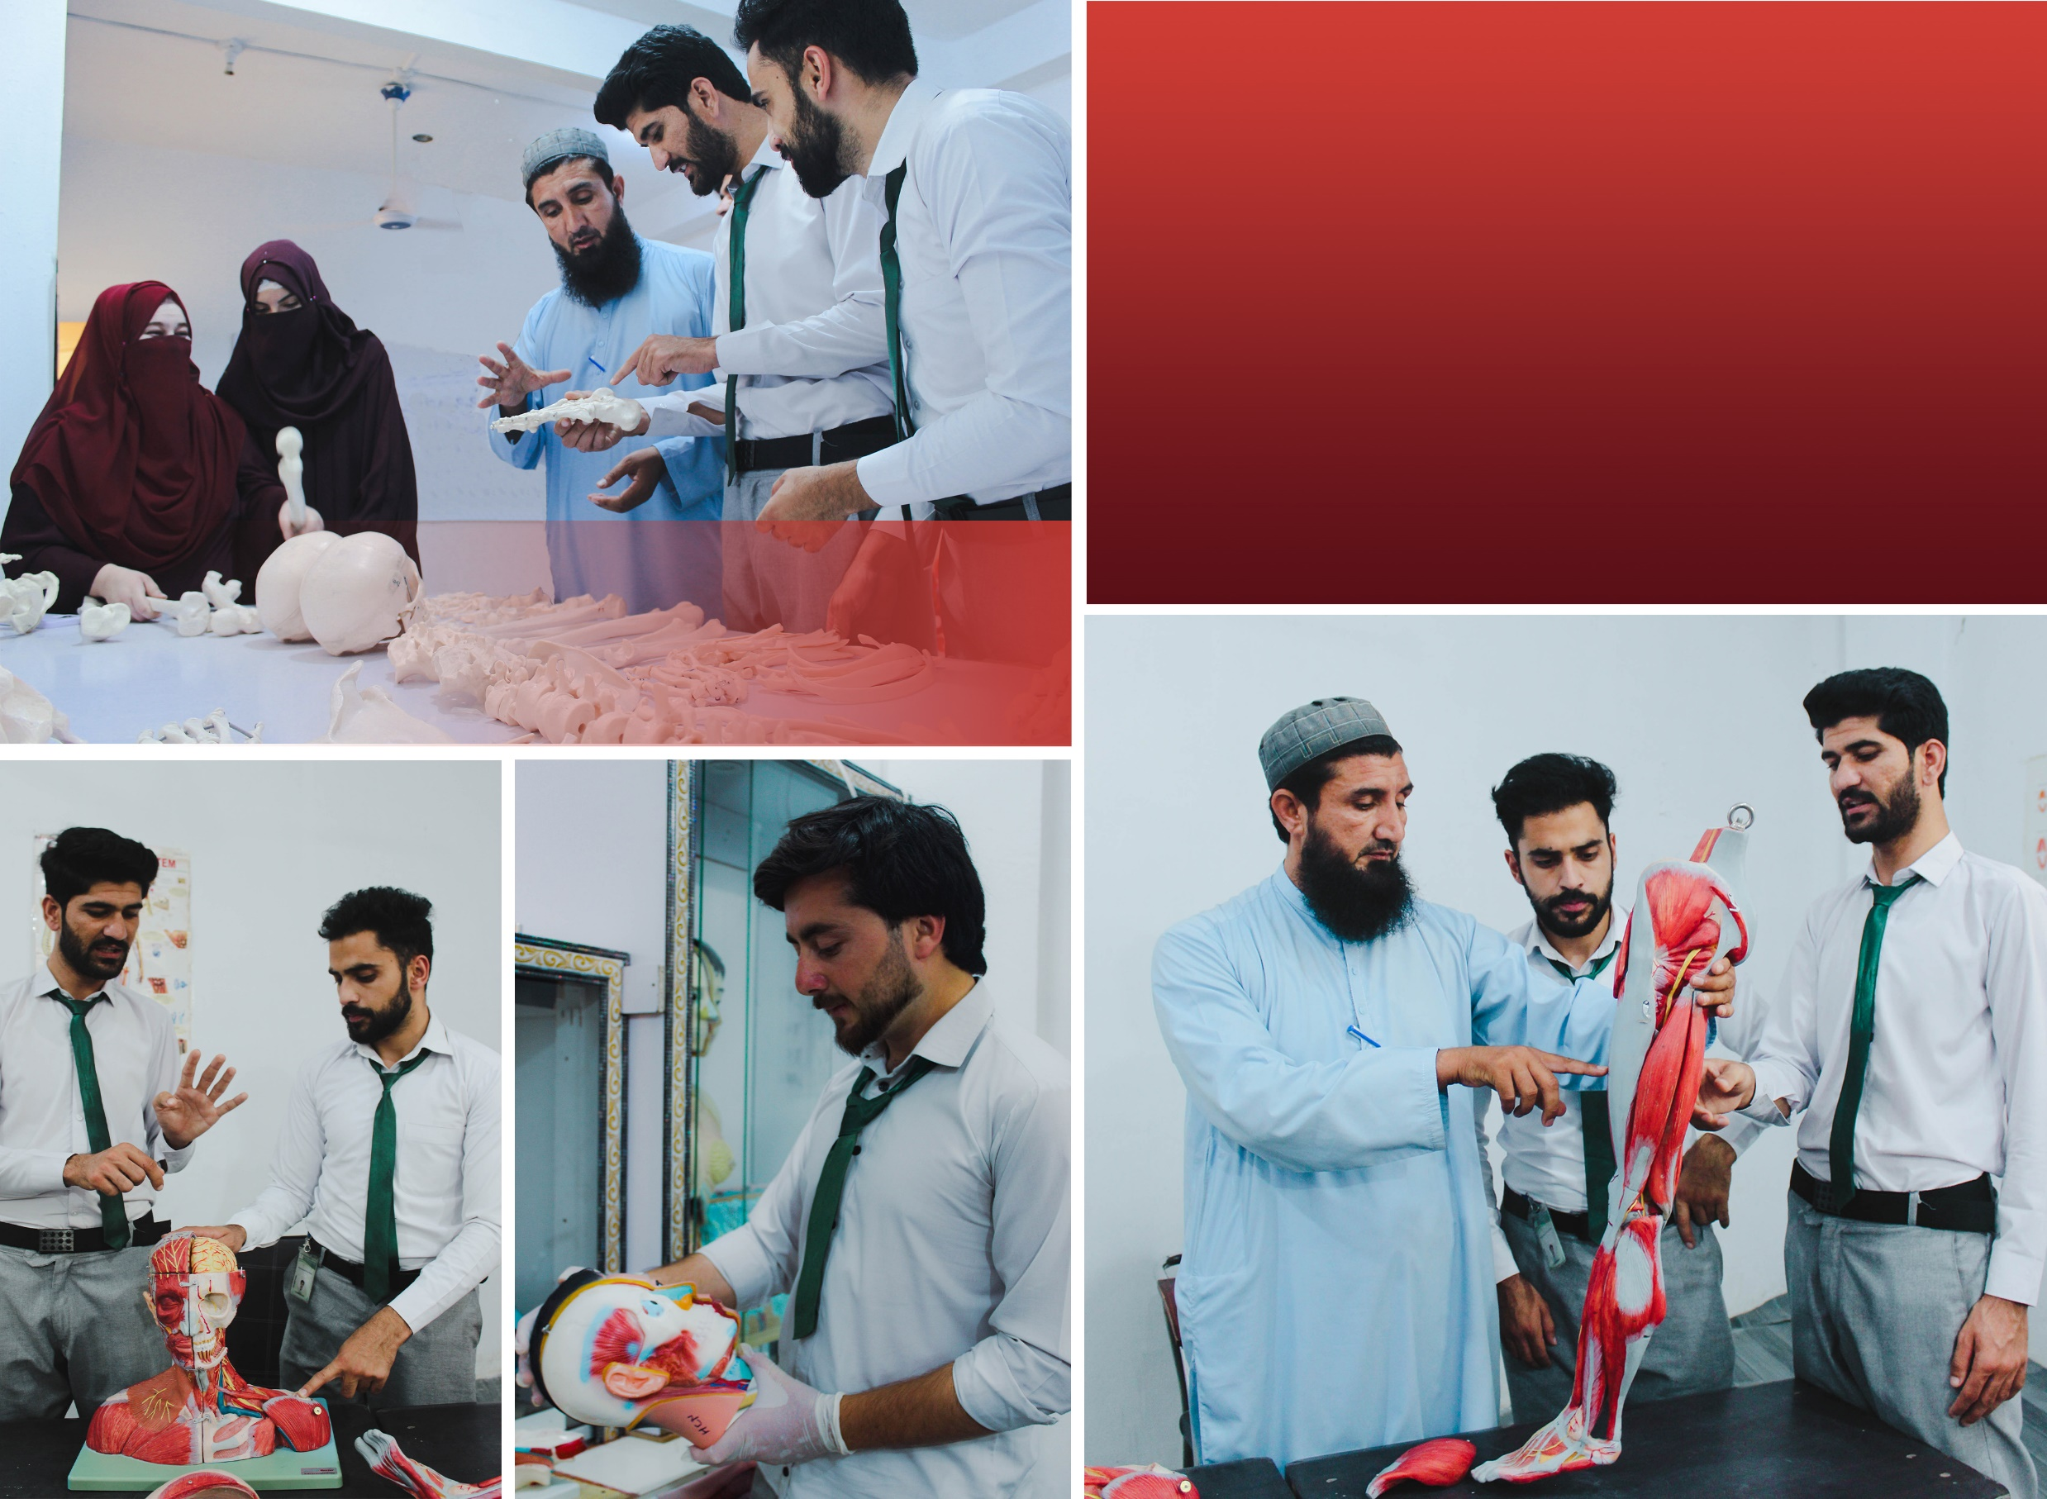

Keeping in view the college’s aim to provide the highest quality education, the college has furnished a separate, completely stocked and standardized anatomy lab/museum.

The teachers and students are always encouraged to make full use of the lab in order to enrich the quality of study even further.

Anatomy Lab

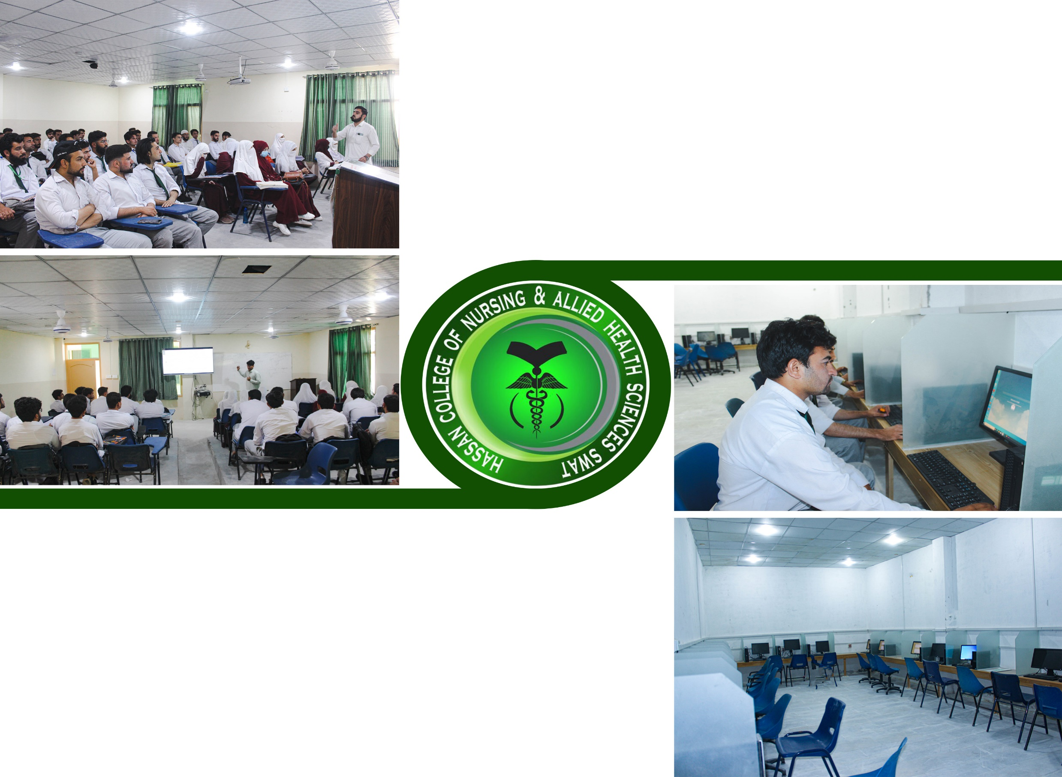
Classrooms

The college provides state of the art classrooms. LED screens have been installed for better viewing and sound systems are installed as well which ensure proper lecture delivery.

Computer Lab

Our computer lab was recently overhauled with modern, up-to-date computer systems, fiber optic internet connection and extended floor area.
The new lab is in line with the upcoming online exam system of the Khyber Medical university.

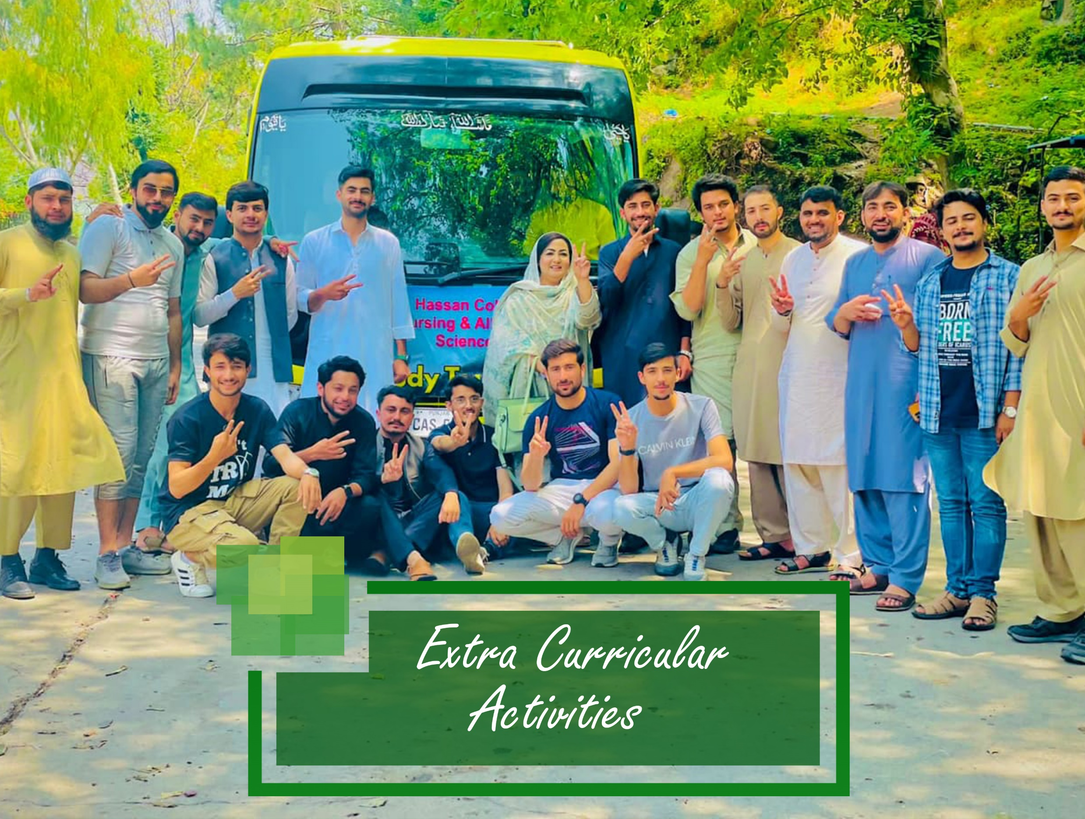

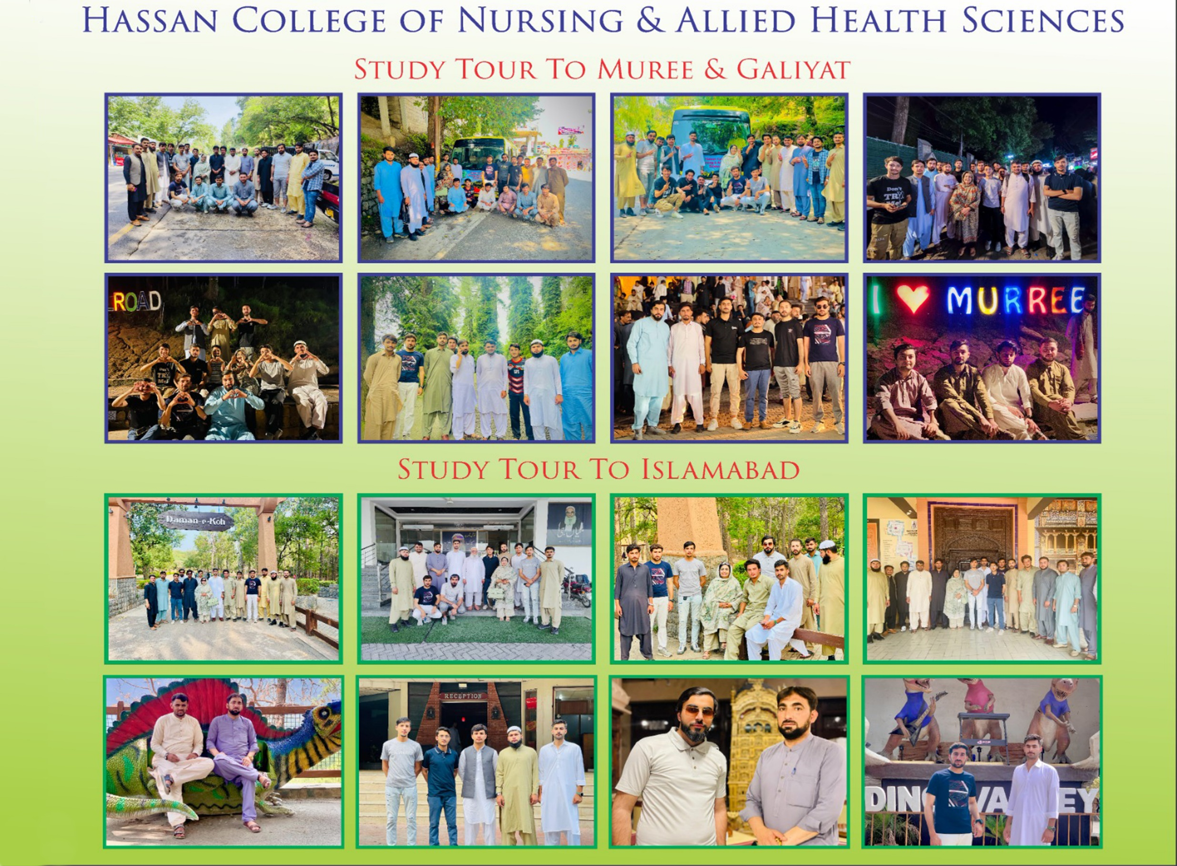




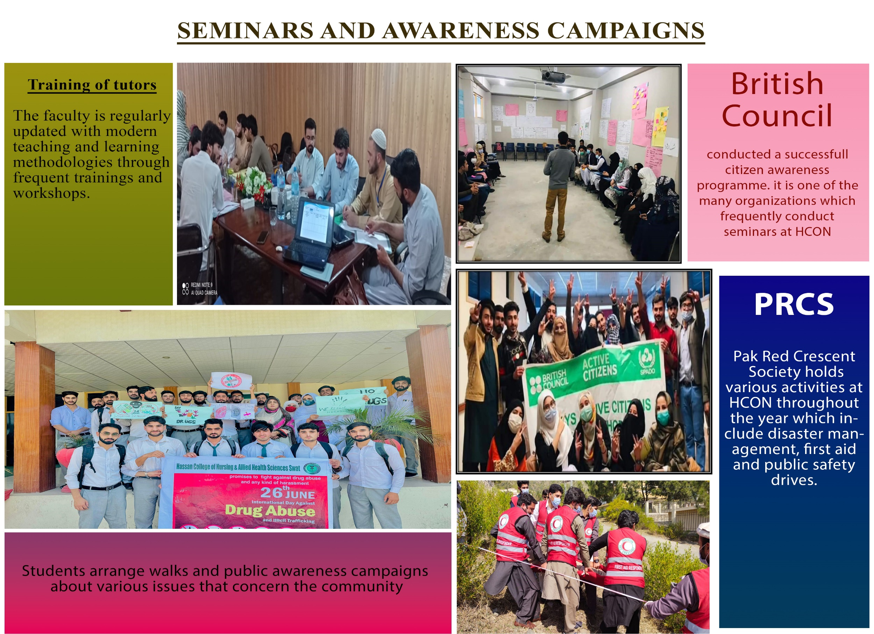


Academic Programs

The college is presently offering the following programs:

- 4 YEARS BACHELOR OF SCIENCE IN NURSING (Generic BSN) DEGREE PROGRAM
- POST RM BSM (IN PROGRESS)
- 2 YEARS DIPLOMA IN CERTIFIED NURSING ASSISTANT (CNA)
- 2 YEARS Lady Health Visitor (LHV) DIPLOMA
- 18 MONTHS CMW DIPLOMA
- 1 year TTB Ultrasound certification

BACHELOR OF SCIENCE IN NURSING (04 YEARS BSN) DEGREE PROGRAM
The BSN degree program is designed to prepare nurses who can provide evidence-based safe care. The graduate of this program will be critical thinkers and leaders in the prevention of illness and promotion of health in hospital as well as in community. Graduates of this program will have the educational foundation to pursue advanced study such as the master's degree and Ph.D. This program is spread over 8 semesters.

BASIC ACADEMIC REQUIRMENTS FOR BSN PROGRAMME
  - Secondary School Certificate (with science subjects including Biology, Physics, Chemistry, Mathematics) or equivalent with at least 55% Marks.
  - Higher Secondary School Certificate (FSc. Pre-Medical) or an equivalent qualification from a recognized board of education with at least 50% marks.
GENERAL ELIGIBILITY
- Age limits 17-30 years at the time of closing date of application.
- Genders both male and female
- Nationality Pakistani

MERIT COMPILATION AND WEIGHTAGE FORMULA
Every eligible applicant will have to appear in KMU Centralized Admission Test (KMU-CAT). 40 percent weightage in calculating the final merit for the admission will be given to KMU-CAT results and remaining 60% weightage will be given to HCN’s admission policy [25 % weightage to FSc. (Pre-Medical) + 25 % to Matric (Science) and 10% to interview].
Disclaimer: Under special circumstances, interviews may be arranged in batches.in which case the merit formula will be applied on individual batches.

SEATS DISTRIBUTION
There are 75 seats on open merit with ratio of 50% male and 50% female candidates. In case the seats remain vacant due to non-availability of the specific gender in specific quota, the seat will be filled by the candidates of opposite gender.

EXAMINATIONS RULES:
For Degree Programs: The examination rules and regulations of KMU shall apply which are available on the KMU Website: www.kmu.edu.pk

FEE STRUCTURE FOR GENERIC BSN DEGREE PROGRAM
Admission:
S. No | ITEMS | AMOUNT
1. | Admission Fee | Rs. 75,000 Per Program
2. | Tuition fee | Rs. 120,000 Per semester
3. | Recreation fund | Rs. 2,000 one time
4. | Library funds | Rs. 5,000 one time
5. | Nursing skill lab/Science Lab fund | Rs. 5,000 one time
8. | Internal Examination fee | Rs. 3,000 one time
 | TOTAL COLLEGE DUES IN 1ST SEMESTER: | 210,000/-
Semester fee:
Semester 2 | 120,000/-
Semester 3 | 130,000/-
Semester 4 | 130,000/-
Semester 5 | 140,000/-
Semester 6 | 140,000/-
Semester 7 | 160,000/-
Semester 8 | 160,000/-

Statutory Bodies /University Dues will be paid by the students as per their commencement (Registration, examination, affiliation Retention etc.)

INTRODUCTION TO LADY HEALTH VISITOR PROGRAM:
Lady health visitor (LHV) is a community health worker who works to improve the health of the community. She closely works with community people to ensure access to primary health care.
After successful completion of prescribed course she will acquire diploma recognized by Pakistan Nursing Council. This is two years diploma program aiming to prevent diseases and promote the health of the individual families and communities with special emphasis on maternal and child health. They work in collaboration with other health care agencies to improve the public heath of their assigned area.

Objectives of the course:
To prepare health care workers who can:

- Prevent illness and promote health of individual families and communities by creating awareness by utilizing formal and informal ways of health teachings
- Reduce the maternal mortality and child mortality rate in the country
- Provide antenatal and postnatal safe care to mother and child
- Provide family planning services to the community
- Ensure safe and healthy motherhood throughout the pregnancy and after birth
- Perform normal veginal delivery by utilizing all the safety measures
- Utilize evidence based knowledge in her practices weeks
- Gather basic data/information from community and report to the concerned authorities

INTRODUCTION TO CMW PROGRAM:
The CMW education program is an eighteen months midwifery course that has been designed for training rural females as midwives who can provide maternal and newborn care to women and children of their communities. After successful completion of prescribed course she will acquire diploma recognized by Pakistan Nursing Council.

Goals and Objectives of the course:
The goal of this midwifery education course is to contribute towards improvement in the health of the mothers and children and bring reduction in maternal and neonatal mortality.
Objectives of the programme are to:

- Prepare competent community midwives

- Integrate CMWs in Pakistan’s Health Care system

INTRODUCTION TO CERTIFIED NURSING ASSISTANT (CNA) (02 YEARS) DIPLOMA PROGRAM

The CNA is a 2 year Diploma education program that offers knowledge, skills and professional attitude at lower cost as compare to RN. Upon completion the CNA will be a safe clinical nurse, who can provide care at primary, secondary and tertiary levels in association with RN in hospitals and community settings.

Duration of Course:
Students enrolled in Private/government institutions for 2years (24 month)

Eligibility:
The Applicant must meet one of the following academic levels:
  - FSc 45% minimum
  - FA 45% minimum
  - Metric with Science 45% minimum
Matric with Arts 50% minimum (for remote area)

Nationality: Pakistani

Age:
Applicant up to the age of 30 years will be considered, further relaxation up to five years could be obtained from respective university/government. In exceptional cases for further relaxation of age PNC approval can be taken.

COLLEGE RULES AND REGULATIONS
Every student admitted to HCNS must follow rules of the HCN.
- To sit in exam, 85% attendance for theory and 100% attendance on clinical.

- Student absent from clinical, must have to makeup of missing clinical.

- Students must have to follow dress code.

- Students must display their ID cards all the time in campus.

- In case of illness, medical certificate of a public Sector Hospital must be attached with application.

- Students will not be allowed to sit in the exam unless they cleared all the dues.

- No political activities are allowed to the students of HCN.

- Socially unacceptable activities and raging in any form is prohibited.

- Students have to submit all the written assignment in soft form through email.

- The college has zero% tolerance policy in plagiarism.

- The college has zero% tolerance policy towards any physical or verbal abuse, any kind of harassment among students, and any misbehavior with thestaff, faculty members and administration staff.

- Other government rules and regulations notified by administration from time to time will be applicable accordingly.

- In terms of assignments submission rules, assignments submission after due date will lead to deduction of 2% marks/day
ADMISSION/GENERAL POLICIES AND INFORMATION

- The admission policy of the HCN based on merit. Students selected on merit will be enrolled to concerned program. The HCN reserves the right to examine each applicant’s suitability for program.
- A candidate seeking admission in any of the program shall apply on a prescribed form. The candidate shall submit the application form along with attested photocopies of all relevant documents as mentioned in the application form.
- If a candidate did not report to the institution within one week of selection and failed to submit the prescribed semester fee within one week then his/her admission will be considered as canceled and the next candidate on the top of waiting list will be called for admission. This decision will not be challengeable in any court of law.

Terms of References
- Selection Committee will be responsible for the admission process and final selection of the candidates.
- Selection committee’s recommendations will be final

MIGRATION TO OTHER COLLEGE
The migration to any affiliated or constituent institute of KMU is subject to the following conditions.
- Migration is only allowed after completion of minimum 4 and before a maximum of 6 semesters.
- The student seeking migration has to pay the fee of remaining semesters as liquidated damages irrespective of the conditions or reasons for their migration.
- As per KMU, migration is subject to parent institute’s No Objection Certificate (NOC). The college can withhold this NOC without providing any grounds for it.
- The student must satisfy the rules and regulations of KMU regarding migration in addition to those noted above.

UNIFORM POLICY FOR DEGREE PROGRAM:
Male Students:
White shirt with full sleeves, Grey Pants, black shoes, white socks, and gray sweater and coat in winter season.

Female Students:
Plain Maroon Shirt with full sleeves, White Shalwar, White Dupatta/white Scarf, over coat, black shoes, and white socks.

UNIFORM POLICY FOR CNA DIPLOMA PROGRAM:
As per PNC white shalwar, shirt with half sleeves and pink head cover
Note: Uniform on clinical area as per PNC recommendation.
FEE REFUND POLICY:
If a student admitted in the college wants to cancel his/her admission within one week of submission of fee the college will deduct 20% from the fee; after two weeks 30%; after three weeks no fee will be returned.

POLICY AGAINST HARASSMENT:
(I) Sexual harassment is prohibited at HCON Swat and constitutes a punishable offence under the Sexual Harassment Policy of HCON Swat and applicable law. The Protection Against Harassment of Women at the Workplace Act, 2010.
(2) Sexual harassment is demeaning to human dignity and is unacceptable in a healthy work and academic environment, specifically one in which scholarly pursuit may flourish. HCON Swat will not tolerate sexual harassment of any member of the College, as defined in Clause 5, and will strive through education and deterrence to create an environment free from such behavior on its premises.
(3) HCON Swat affirms the right of every member of the College to live, study, and work in an environment that is free from sexual harassment. Behavior constituting sexual harassment as defined in the Policy and the 2010 Act is incompatible with all recognized standards of professional ethics and with behavior appropriate to an institution of higher learning.
(4) All persons entrusted with authority by HCON Swat have a particular obligation to ensure that there is no misuse of that authority in any action or relationship.
(5) HCON Swat recognizes its legal and moral responsibility to protect all of its members from sexual harassment and to take action if such harassment does occur. To these ends, HCON Swat has developed a Policy on, and procedures for, dealing with complaints of sexual harassment, including a range of disciplinary measures up to and including dismissal.
(6) HCON Swat prohibits reprisals or threats of reprisal against any member of the College who avails of this Policy or participates in proceedings held under its ambit. Any individual or body found to be making such reprisals or threats will be subject to disciplinary action.
(7) The intention of this Policy and its procedures is to prevent sexual harassment from taking place, and, where necessary, to act upon complaints of sexual harassment promptly, fairly, judiciously, and with due regard to confidentiality for all parties concerned
(8) All administrators, deans, managers, department chairs, and others in supervisory or leadership positions have an obligation to be familiar with, and to uphold, this Policy and its procedures, along with informing members of their staff about its existence and applicability.
(9) This Policy is adopted, among others, pursuant to the provisions of the 20I0 Act. The Annexures to the Policy are an integral part of the Policy.

(10) This Policy shall supersede all other terms, conditions, agreements and arrangements.
(12) References to Clauses are, unless the context otherwise requires, references to Clauses in or to this Policy.
Further details about anti-harassment committee can be found on our website and free copy of the policy can be obtained from the students’ affairs office.
Details of members can be found in “Committees section” of this document.

ANTI-NARCOTICS POLICY
Possession: Possession of narcotics, controlled substances or sedatives without authorization will result in heavy fines and even termination from the college.
Dealing: Anyone found guilty of dealing or procuring narcotics will be
immediately expelled from college. Moreover, they will be handed over to the law enforcement.
Disseminating: Anyone found guilty of sharing or asking for information regarding procurement of narcotics will face heavy fines or termination from college.
Withholding information: Anyone found guilty of withholding information regarding existence, whereabouts or dealing from college administration will be treated as an accomplice to aforementioned acts and will be treated as such.
The anti-drug/ tobacco officer along with disciplinary committee will decide upon above matters.

